FACILITATION GUIDE: MENTAL HEALTH {1 hour 30 minutes)
Objective:
- Understand mental health as the balance and alignment between the self and four key domains.
- Reflect on their own experiences and relationships within these domains.
- Identify stressors and coping strategies for better mental health.
- Develop personal strategies to improve alignment within these domains.

Introduction
This facilitator’s guide provides structured guidance for leading discussions and activities on mental health using the framework illustrated in the provided image. It explores mental health as the degree of adjustment between the self and four key domains: Environment, Social, Reality, and Mental.
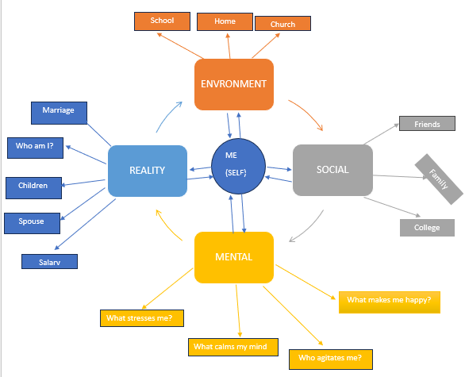

Pre-Requisites
Participants should have an appreciation of Psychosocial Support and its principles.

SESSION 1: INTRODUCTION (15 minutes)
AIM: Participants to gain an appreciation of the topic of the day and be able to link it with the their own life experiencies.
INTRODUCTION OF PARTICIPANTS
NB Facilitator to engage participants in self introductions in a manner that has a particular bias to the topic of the day
Example: Participant’s name and mention of one form of self-care activity.

Participants to go through an experiential learning tower: Build A Tower
Participants will build a tower using cups, rope and elastic bands.

Session 2: Understanding the Domains of Mental Health (1 hour 15 minutes)

1. The Social Domain
Definition:
This domain focuses on relationships and social interactions that shape mental well-being.

Key Elements:
(Facilitator should be able to engage participants in revealing the particulars of their social lives.)
(Facilitator should emphasize on Connectedness and the ability to be connected to the next person)
Examples:
Friendships and social support: The role of peer networks in providing emotional comfort.
Family relationships and communication: The impact of family dynamics on mental health.
Workplace or academic relationships: How professional connections can influence stress and satisfaction.

Facilitator Discussion Points:

Ask: “What role do friendships and family play in your mental health?”
Encourage: Reflection on how different social relationships affect emotions and coping.
Emphasize: The need for strong social support networks and healthy communication skills, possibly introducing resources for building these skills.

2. The Environmental Domain
Definition:
This domain includes external factors that influence mental health, such as home life, school, work, and community.
Key Elements:
(Facilitator should be able to engage participants in revealing the environments they are usually in such as home, church, school, work etc.)
(Facilitator should emphasize on The Sense of Safety, Does the individual feel safe in the environment they are in?)

Examples:
- A supportive home environment vs. A stressful or chaotic home.
- Work or school pressure impacting stress levels.
- Cultural and religious influences on mental health.

Facilitator Discussion Points:
Ask: “How does your environment affect your stress levels and emotions?”
Encourage: Participants to share examples of both positive and negative influences from their environment.
Emphasize: The importance of creating supportive and healthy environments, and discuss ways to enhance these settings.

3. The Mental Domain
Definition:
This domain is about thoughts, emotions, and self-regulation. It involves self-reflection on stressors and coping strategies.
Key Elements:
(Facilitator should be able to engage participants in revealing stressful situations they have been in and also situations where they felt at ease)
(Facilitator should emphasize on The Ability To Remain Calm Under A Stressful Situation)

Key Questions for Self-Reflection:
- What stresses me?
- What calms my mind?
- What makes me happy?
- Who agitates me?

Facilitator Discussion Points:

Ask: “What do you do when faced with stress?”
Encourage: Sharing of personal coping mechanisms and strategies for emotional regulation.
Emphasize: The importance of emotional regulation and mindfulness practices, introducing techniques such as deep breathing or journaling.

4. The Reality Domain
Definition:
This domain relates to personal identity and life responsibilities, shaping self-perception and emotional stability.
Key Elements:
(Facilitator should be able to engage participants in identifying their realities; marriage, school, little salary and be in a place to guide them in identifying the good realities)
(Facilitator should emphasize on The Ability To Hope, that no matter the realities they come across there is always light at the end of the tunnel.)

Key Aspects:
Understanding self-identity: Exploring questions like “Who am I?” and “What do I value?”
Life roles: Balancing roles such as marriage, career, and financial responsibilities.
Work-life balance: Strategies for managing time and energy effectively.

Facilitator Discussion Points:
Ask: “Do you feel in control of your life responsibilities? Why or why not?”
Encourage: Participants to discuss challenges they face in balancing different aspects of their reality.
Emphasize: The importance of personal growth, self-awareness, and setting realistic goals in managing stress.

Session 3: Experiential Learning Activities (1 hour)
(To be conducted after the discussions for deeper engagement)
Activity 1: Mapping the Self and the Domains
Objective:
Help participants visually explore their relationship with the four domains.

Instructions:
1. Provide participants with a blank version of the image.
2. Ask them to map their own experiences by labeling each domain with personal reflections.
3. Reflection questions:
- How do I perceive my relationship with each domain?
- Where do I feel balanced or imbalanced?
- What factors contribute to this alignment or misalignment?
4. Facilitate a group discussion on their findings.

Facilitator Tips:
Encourage honesty and personal insights.
Guide participants to see patterns in their mental health influences.
Reinforce the importance of self-awareness and continuous reflection.

Challenge Course activities
- Balancing Beam
- Balancing Wheel (to show the relationship between the 4 domains and the self at the centre)

Conclusion: Mental Health as the Degree of Adjustment
Final Definition:
Mental health is the degree of adjustment between the self and the surrounding domains—environment, social, reality, and mental. A mentally healthy person can adapt, regulate emotions, and maintain balance across these domains.

Key Takeaways:
- Mental health is dynamic and influenced by multiple factors, requiring ongoing attention.
- Self-awareness and proactive adjustments can significantly improve mental well-being.
- Small intentional actions, such as setting boundaries or seeking support, can create a lasting impact on mental health.

Mental health is influenced by the interplay of four major domains:
- Environmental Domain: The physical and situational factors that shape experiences, such as living conditions, work environment, and community resources.
- Social Domain: Relationships and social support systems that provide emotional and practical assistance, including family, friends, and colleagues.
- Reality Domain: Personal identity, life roles, and responsibilities that contribute to self-perception and emotional stability.
- Mental Domain: The cognitive and emotional processes involved in self-regulation, mindfulness, and coping strategies.
These domains affect how individuals experience well-being and cope with life’s challenges.

Facilitator Tips for Engagement:
Ask: “Which domain do you think has the biggest impact on mental health?”
Emphasize: The interconnectedness of these domains and how an imbalance in one can affect the others.
Encourage: Participants to reflect on where they feel most balanced and where they struggle, fostering an open dialogue.

